Name(s):___________________________________________Class_____Date______
DECA Facts Internet Scavenger Hunt

Directions: Students may use the following websites in your DECA FACTS Discovery: www.deca.org and http://www.gadeca.org.
You can write your answers on the back.

- What is the mission of DECA?
- Where are the National DECA Headquarters located? (Street address, city, state & zip code?)
- The official magazine of National DECA is called _________________.
- The four regions of National DECA are _________________, ________________, _________________, __________________.
- Which region does GA DECA belong to?
- Each state has one Advisor who oversees all DECA Chapters in that state. GA’s State Advisor is _____________________.
- The 2014-2015 National DECA Officers for the High School Division are:
  - President: ______________________; From which state? _________
  - Vice Pres./North Atlantic Region: __________________ State? ____
  - Vice Pres./Central Region: _________________________State? ____
  - Vice Pres./Southern Region: _______________________State?____
  - Vice Pres./Western Region: ________________________ State? ___
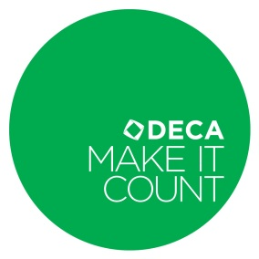
- The four points of the DECA Diamond are ______________________, ___________________________, _______________________ and ___________________________.
- Describe the official DECA Emblem.
- What are the official DECA colors?
- The national DECA tagline is _____________________________________.
- DECA was established nationally in what year?
- When was the first National DECA Conference held?
- Where is the national “birthplace” of DECA
- What are the five membership divisions of DECA? (HINT: ways persons can become members)
- Name the division of DECA that students can gain membership in college.
- Name at least 5 corporate sponsors of DECA who also offer scholarships to DECA members.
- Besides the regional level, name two other levels of DECA where members are able to compete.
- When is the 2014-2015 International Career Development Conference (National’s) going to be held? (Dates?)
- Where is the 2014-2015 ICDC (National’s) going to be held? (city, state)
- What is DECA Images?
- Locate “competitive events” on www.deca.org.
  - Name 4 “marketing research” competitive events
  - Name 5 “ chapter team” competitive events
  - Name at least 5 “individual series” events.
- What is DECA’s theme for this year’s Membership campaign?
- Name the 2013-2014 GA State Action Team (Hint: GA State officers).

